**Observable Trends:**

1. In gender demographics, out of the total players the majority players are male(84%) and less proportion of female players(14%).

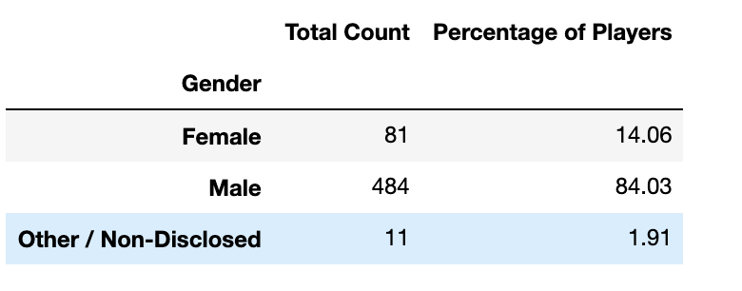

2) Maximum percent of players falls within 20-24 age group with (44.79%) and the secondary is within 15-19 group with (18.58%)

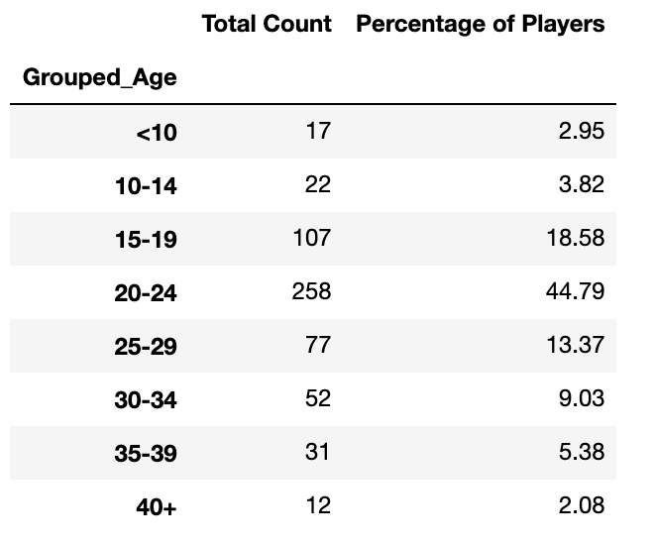

1. “Oathbreaker,LastHope of the breaking strom” this item has the highest purchase count with $50.76 of total purchase value and “Fiery Glass Crusader” is second item which has $41.22 of total purchase

